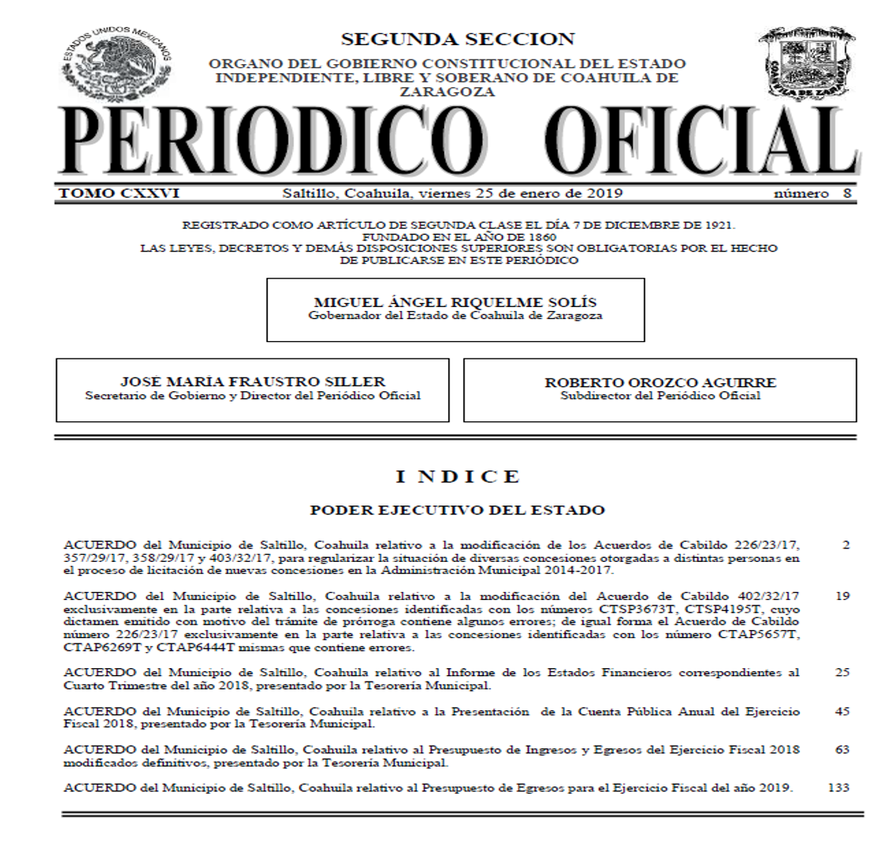

 |  | PERCEPCIONES |  |  |  |  |  | DEDUCCIONES
CATEGORÍA / PUESTO |  | SUELDO (01) | INFRAESTRUCTURA | DESPENSA (29) | AYUDA DE TRANSPORTE (36) | TOTAL PERCEPCIONES |  | APORTACIÓN A PENSIONES | IMPUESTO SOBRE LA RENTA | APORTACIÓN A SERVICIO MEDICO |  | APORTACIÓN PATRONAL A PENSIONES |  | SUELDO NETO
PERSONAL DE MANDO Y PERSONAL TÉCNICO Y OPERATIVO DE NUEVA GENERACIÓN
ALCALDE |  | 38,126.00 | 73,230.49 | 50.00 | 10.00 | 111,416.49 |  | 3,431.34 | 30,189.62 | 1,334.41 |  | 3,431.34 |  | 76,461.12
CUERPO EDILICIO |  | 29,274.00 | 50,910.32 | 50.00 | 10.00 | 80,244.32 |  | 2,634.66 | 19,929.87 | 1,024.59 |  | 2,634.66 |  | 56,655.20
SA-TES |  | 26,273.00 | 66,912.74 | 50.00 | 10.00 | 93,245.74 |  | 2,364.57 | 24,090.32 | 919.56 |  | 2,364.57 |  | 65,871.29
DA |  | 26,273.00 | 50,726.38 | 50.00 | 10.00 | 77,059.38 |  | 2,364.57 | 18,910.69 | 919.56 |  | 2,364.57 |  | 54,864.56
SDA |  | 23,025.00 | 37,978.07 | 50.00 | 10.00 | 61,063.07 |  | 2,072.25 | 14,028.35 | 805.88 |  | 2,072.25 |  | 44,156.59
SDB |  | 23,025.00 | 31,969.77 | 50.00 | 10.00 | 55,054.77 |  | 2,072.25 | 12,225.86 | 805.88 |  | 2,072.25 |  | 39,950.78
SDC |  | 23,025.00 | 26,246.07 | 50.00 | 10.00 | 49,331.07 |  | 2,072.25 | 10,508.75 | 805.88 |  | 2,072.25 |  | 35,944.19
COA |  | 17,734.00 | 21,984.73 | 50.00 | 10.00 | 39,778.73 |  | 1,596.06 | 7,643.05 | 620.69 |  | 1,596.06 |  | 29,918.93
COB |  | 17,734.00 | 18,336.82 | 50.00 | 10.00 | 36,130.82 |  | 1,596.06 | 6,681.32 | 620.69 |  | 1,596.06 |  | 27,232.75
COC |  | 17,734.00 | 14,764.46 | 50.00 | 10.00 | 32,558.46 |  | 1,596.06 | 5,841.10 | 620.69 |  | 1,596.06 |  | 24,500.61
JDA |  | 13,229.00 | 12,132.36 | 50.00 | 10.00 | 25,421.36 |  | 1,190.61 | 4,162.45 | 463.02 |  | 1,190.61 |  | 19,605.28
JDB |  | 13,229.00 | 9,597.96 | 50.00 | 10.00 | 22,886.96 |  | 1,190.61 | 3,595.20 | 463.02 |  | 1,190.61 |  | 17,638.14
JDC |  | 13,229.00 | 6,739.00 | 50.00 | 10.00 | 20,028.00 |  | 1,190.61 | 2,984.53 | 463.02 |  | 1,190.61 |  | 15,389.85
JSA |  | 9,557.00 | 8,067.00 | 50.00 | 10.00 | 17,684.00 |  | 860.13 | 2,483.85 | 334.50 |  | 860.13 |  | 14,005.53
JSB |  | 9,557.00 | 6,388.54 | 50.00 | 10.00 | 16,005.54 |  | 860.13 | 2,125.33 | 334.50 |  | 860.13 |  | 12,685.58
ATO01 |  | 8,770.00 | 5,648.00 | 50.00 | 10.00 | 14,478.00 |  | 789.30 | 1,799.05 | 306.95 |  | 789.30 |  | 11,582.70
ATO02 |  | 8,605.00 | 4,310.00 | 50.00 | 10.00 | 12,975.00 |  | 774.45 | 1,478.00 | 301.18 |  | 774.45 |  | 10,421.37
ATO03 |  | 7,972.00 | 3,535.00 | 50.00 | 10.00 | 11,567.00 |  | 717.48 | 1,192.50 | 279.02 |  | 717.48 |  | 9,378.00
ATO04 |  | 7,427.00 | 2,853.00 | 50.00 | 10.00 | 10,340.00 |  | 668.43 | 972.62 | 259.95 |  | 668.43 |  | 8,439.01
ATO05 |  | 6,588.00 | 2,556.00 | 50.00 | 10.00 | 9,204.00 |  | 592.92 | 784.93 | 230.58 |  | 592.92 |  | 7,595.57
ATO06 |  | 5,989.00 | 2,184.93 | 50.00 | 10.00 | 8,233.93 |  | 539.01 | 649.95 | 209.62 |  | 539.01 |  | 6,835.36
ATO07 |  | 5,445.00 | 1,600.99 | 50.00 | 10.00 | 7,105.99 |  | 490.05 | 273.69 | 190.58 |  | 490.05 |  | 6,151.68
ATO08 |  | 4,950.00 | 1,375.47 | 50.00 | 10.00 | 6,385.47 |  | 445.50 | 195.30 | 173.25 |  | 445.50 |  | 5,571.42
ATO09 |  | 4,500.00 | 1,049.91 | 50.00 | 10.00 | 5,609.91 |  | 405.00 | 69.83 | 157.50 |  | 405.00 |  | 4,977.58
PERSONAL DE MANDO Y PERSONAL TÉCNICO Y OPERATIVO DE TRANSICIÓN
DA |  | 26,273.00 | 48,021.80 | 50.00 | 10.00 | 74,354.80 |  | 525.46 | 18,045.22 | 919.56 |  | 4,072.32 |  | 54,864.57
SDA |  | 23,025.00 | 35,675.57 | 50.00 | 10.00 | 58,760.57 |  | 460.50 | 13,337.60 | 805.88 |  | 3,568.88 |  | 44,156.59
SDB |  | 23,025.00 | 29,667.27 | 50.00 | 10.00 | 52,752.27 |  | 460.50 | 11,535.11 | 805.88 |  | 3,568.88 |  | 39,950.78
SDC |  | 23,025.00 | 23,943.57 | 50.00 | 10.00 | 47,028.57 |  | 460.50 | 9,818.00 | 805.88 |  | 3,568.88 |  | 35,944.19
COA |  | 17,734.00 | 20,225.94 | 50.00 | 10.00 | 38,019.94 |  | 354.68 | 7,125.64 | 620.69 |  | 2,748.77 |  | 29,918.93
COB |  | 17,734.00 | 16,713.68 | 50.00 | 10.00 | 34,507.68 |  | 354.68 | 6,299.56 | 620.69 |  | 2,748.77 |  | 27,232.75
COC |  | 17,734.00 | 13,141.31 | 50.00 | 10.00 | 30,935.31 |  | 354.68 | 5,459.34 | 620.69 |  | 2,748.77 |  | 24,500.61
JDA |  | 13,229.00 | 10,921.86 | 50.00 | 10.00 | 24,210.86 |  | 264.58 | 3,877.98 | 463.02 |  | 2,050.50 |  | 19,605.28
JDB |  | 13,229.00 | 8,420.40 | 50.00 | 10.00 | 21,709.40 |  | 264.58 | 3,343.67 | 463.02 |  | 2,050.50 |  | 17,638.14
JDC |  | 13,229.00 | 5,561.44 | 50.00 | 10.00 | 18,850.44 |  | 264.58 | 2,733.00 | 463.02 |  | 2,050.50 |  | 15,389.85
JSA |  | 9,557.00 | 7,216.30 | 50.00 | 10.00 | 16,833.30 |  | 191.14 | 2,302.14 | 334.50 |  | 1,481.34 |  | 14,005.53
JSB |  | 9,557.00 | 5,537.84 | 50.00 | 10.00 | 15,154.84 |  | 191.14 | 1,943.62 | 334.50 |  | 1,481.34 |  | 12,685.58
ATO01 |  | 8,770.00 | 4,867.35 | 50.00 | 10.00 | 13,697.35 |  | 175.40 | 1,632.30 | 306.95 |  | 1,359.35 |  | 11,582.70
ATO02 |  | 8,605.00 | 3,544.04 | 50.00 | 10.00 | 12,209.04 |  | 172.10 | 1,314.40 | 301.18 |  | 1,333.78 |  | 10,421.37
ATO03 |  | 7,972.00 | 2,855.13 | 50.00 | 10.00 | 10,887.13 |  | 159.44 | 1,070.66 | 279.02 |  | 1,235.66 |  | 9,378.00
ATO04 |  | 7,427.00 | 2,227.02 | 50.00 | 10.00 | 9,714.02 |  | 148.54 | 866.53 | 259.95 |  | 1,151.19 |  | 8,439.01
ATO05 |  | 6,588.00 | 2,007.00 | 50.00 | 10.00 | 8,655.00 |  | 131.76 | 697.09 | 230.58 |  | 1,021.14 |  | 7,595.57
ATO06 |  | 5,989.00 | 1,714.52 | 50.00 | 10.00 | 7,763.52 |  | 119.78 | 598.77 | 209.62 |  | 928.30 |  | 6,835.36
ATO07 |  | 5,445.00 | 1,173.31 | 50.00 | 10.00 | 6,678.31 |  | 108.90 | 227.16 | 190.58 |  | 843.98 |  | 6,151.68
ATO08 |  | 4,950.00 | 940.56 | 50.00 | 10.00 | 5,950.56 |  | 99.00 | 106.89 | 173.25 |  | 767.25 |  | 5,571.42
ATO09 |  | 4,500.00 | 662.53 | 50.00 | 10.00 | 5,222.53 |  | 90.00 | - 2.56 | 157.50 |  | 697.50 |  | 4,977.58
PERSONAL DE MANDO Y PERSONAL TÉCNICO Y OPERATIVO EVENTUAL O TRANSITORIO
ESDA |  | 59,948.91 | - | - | - | 59,948.91 |  | - | 13,694.10 | 2,098.21 |  | - |  | 44,156.59
ESDB |  | 53,624.38 | - | - | - | 53,624.38 |  | - | 11,796.74 | 1,876.85 |  | - |  | 39,950.78
ESDC |  | 47,599.43 | - | - | - | 47,599.43 |  | - | 9,989.26 | 1,665.98 |  | - |  | 35,944.19
ECOA |  | 38,538.89 | - | - | - | 38,538.89 |  | - | 7,271.10 | 1,348.86 |  | - |  | 29,918.93
ECOB |  | 34,826.12 | - | - | - | 34,826.12 |  | - | 6,374.45 | 1,218.91 |  | - |  | 27,232.75
ECOC |  | 31,082.43 | - | - | - | 31,082.43 |  | - | 5,493.94 | 1,087.89 |  | - |  | 24,500.61
EJDA |  | 24,374.66 | - | - | - | 24,374.66 |  | - | 3,916.27 | 853.11 |  | - |  | 19,605.28
EJDB |  | 21,752.30 | - | - | - | 21,752.30 |  | - | 3,352.84 | 761.33 |  | - |  | 17,638.14
EJDC |  | 18,760.17 | - | - | - | 18,760.17 |  | - | 2,713.72 | 656.61 |  | - |  | 15,389.85
EJSA |  | 16,917.85 | - | - | - | 16,917.85 |  | - | 2,320.20 | 592.12 |  | - |  | 14,005.53
EJSB |  | 15,161.21 | - | - | - | 15,161.21 |  | - | 1,944.98 | 530.64 |  | - |  | 12,685.58
EATO01 |  | 13,693.44 | - | - | - | 13,693.44 |  | - | 1,631.46 | 479.27 |  | - |  | 11,582.70
EATO02 |  | 12,147.88 | - | - | - | 12,147.88 |  | - | 1,301.33 | 425.18 |  | - |  | 10,421.37
EATO03 |  | 10,814.07 | - | - | - | 10,814.07 |  | - | 1,057.57 | 378.49 |  | - |  | 9,378.00
EATO04 |  | 9,628.94 | - | - | - | 9,628.94 |  | - | 852.92 | 337.01 |  | - |  | 8,439.01
EATO05 |  | 8,584.06 | - | - | - | 8,584.06 |  | - | 688.05 | 300.44 |  | - |  | 7,595.57
EATO06 |  | 7,696.16 | - | - | - | 7,696.16 |  | - | 591.44 | 269.37 |  | - |  | 6,835.36
EATO07 |  | 6,601.54 | - | - | - | 6,601.54 |  | - | 218.81 | 231.05 |  | - |  | 6,151.68
EATO08 |  | 5,875.83 | - | - | - | 5,875.83 |  | - | 98.76 | 205.65 |  | - |  | 5,571.42
EATO09 |  | 5,146.95 | - | - | - | 5,146.95 |  | - | - 10.78 | 180.14 |  | - |  | 4,977.58
PERSONAL POLICIAL DE NUEVA GENERACIÓN
COMISARIO |  | 26,273.00 | 28,801.00 | 50.00 | 20.00 | 57,115.93 |  | 2,364.57 | 12,844.21 | 919.56 |  | 2,364.57 |  | 40,987.60
OFICIAL |  | 21,422.00 | 19,962.00 | 50.00 | 20.00 | 51,107.62 |  | 1,927.98 | 11,041.72 | 749.77 |  | 1,927.98 |  | 37,388.16
SUBOFICIAL |  | 21,422.00 | 12,535.00 | 50.00 | 20.00 | 45,383.92 |  | 1,927.98 | 9,324.61 | 749.77 |  | 1,927.98 |  | 33,381.57
POLICÍA 1RO |  | 14,062.00 | 14,774.00 | 50.00 | 20.00 | 36,860.38 |  | 1,265.58 | 6,852.91 | 492.17 |  | 1,265.58 |  | 28,249.72
POLICÍA 2DO |  | 11,689.00 | 12,333.00 | 50.00 | 20.00 | 33,348.29 |  | 1,052.01 | 6,026.87 | 409.12 |  | 1,052.01 |  | 25,860.30
POLICÍA 3RO UA |  | 9,557.00 | 11,551.00 | 50.00 | 20.00 | 29,775.93 |  | 860.13 | 5,186.65 | 334.50 |  | 860.13 |  | 23,394.65
POLICÍA 3RO |  | 9,557.00 | 10,477.00 | 50.00 | 20.00 | 23,369.74 |  | 860.13 | 3,698.32 | 334.50 |  | 860.13 |  | 18,476.80
POLICÍA UR |  | 9,557.00 | 8,731.00 | 50.00 | 20.00 | 20,868.12 |  | 860.13 | 3,163.98 | 334.50 |  | 860.13 |  | 16,509.52
POLICÍA UA |  | 9,557.00 | 7,790.00 | 50.00 | 20.00 | 18,009.14 |  | 860.13 | 2,553.30 | 334.50 |  | 860.13 |  | 14,261.21
POLICÍA |  | 9,557.00 | 6,895.00 | 50.00 | 20.00 | 16,226.10 |  | 860.13 | 2,172.44 | 334.50 |  | 860.13 |  | 12,859.03
PERSONAL POLICIAL DE TRANSICIÓN
COMISARIO |  | 26,273.00 | 28,801.00 | 50.00 | 20.00 | 57,115.93 |  | 525.46 | 12,844.21 | 919.56 |  | 4,072.32 |  | 42,826.71
OFICIAL |  | 21,422.00 | 19,962.00 | 50.00 | 20.00 | 51,107.62 |  | 428.44 | 11,041.72 | 749.77 |  | 3,320.41 |  | 38,887.70
SUBOFICIAL |  | 21,422.00 | 12,535.00 | 50.00 | 20.00 | 45,383.92 |  | 428.44 | 9,324.61 | 749.77 |  | 3,320.41 |  | 34,881.11
POLICÍA 1RO |  | 14,062.00 | 14,774.00 | 50.00 | 20.00 | 36,860.38 |  | 281.24 | 6,852.91 | 492.17 |  | 2,179.61 |  | 29,234.06
POLICÍA 2DO |  | 11,689.00 | 12,333.00 | 50.00 | 20.00 | 33,348.29 |  | 233.78 | 6,026.87 | 409.12 |  | 1,811.80 |  | 26,678.53
POLICÍA 3RO UA |  | 9,557.00 | 11,551.00 | 50.00 | 20.00 | 29,775.93 |  | 191.14 | 5,186.65 | 334.50 |  | 1,481.34 |  | 24,063.64
POLICÍA 3RO |  | 9,557.00 | 10,477.00 | 50.00 | 20.00 | 23,369.74 |  | 191.14 | 3,698.32 | 334.50 |  | 1,481.34 |  | 19,145.79
POLICÍA UR |  | 9,557.00 | 8,731.00 | 50.00 | 20.00 | 20,868.12 |  | 191.14 | 3,163.98 | 334.50 |  | 1,481.34 |  | 17,178.51
POLICÍA UA |  | 9,557.00 | 7,790.00 | 50.00 | 20.00 | 18,009.14 |  | 191.14 | 2,553.30 | 334.50 |  | 1,481.34 |  | 14,930.20
POLICÍA |  | 9,557.00 | 6,895.00 | 50.00 | 20.00 | 16,226.10 |  | 191.14 | 2,172.44 | 334.50 |  | 1,481.34 |  | 13,528.02

Deducciones de ley 2019:
a. Impuesto Sobre la Renta de conformidad con las tablas aplicables emitidas por la SHCP.
b. Aportación del 3.5% del sueldo (01) para el servicio médico.
c. Aportaciones del sueldo (01) y clasificación de Empleados de Nueva Generación y de Transición de conformidad con lo establecido en la Ley Orgánica del Organismo Público Descentralizado de la Administración Municipal denominado Dirección de Pensiones y Otros Beneficios Sociales para los Trabajadores al Servicio del Municipio de Saltillo
Prestaciones autorizadas para 2019:
a. Aguinaldo en los mismos términos que el ejercicio fiscal anterior; equivalente a 43 días de salario integrado o su parte proporcional a quienes hubieren prestado sus servicios por menos de un año.
b. Prima vacacional en los mismos términos que el ejercicio fiscal anterior; equivalente al 75% del salario integrado.
c. 3 meses de salario integrado en caso de fallecimiento del trabajador de conformidad con lo establecido por el Código Municipal.
d. Apoyo para gastos de funeral en caso de fallecimiento de padres, hijos cónyuge de un mes de salario integrado, con tope máximo de 250 veces el valor de la unidad de medida y actualización (UMA) para 2018 y un mínimo garantizado de 100 UMA.
e. Estímulos económicos de antigüedad por años de servicio, en los mismos términos que los autorizados en las condiciones generales de trabajo del personal sindicalizado.

